SAKURA SCIENCE EXCHANGE PROGRAM

The Japanese Science and Technology agency funded a twelve day educational excursion to Japan.The students of CITY MONTESSORI SCHOOL,GOMTI NAGAR represented INDIA in the program.

*DAY 1*

*VISIT TO THE HOKKAIDO UNIVERSITY*

*It was an amazing experience to get to know the Japanese science and modern studies program.We had a fascinating opportunity to have a conversation with the top scholars pursuing graduation there.We visited various labs there ;major ones being QUANTUM SCIENCE AND ENGINEERING AND MECHANICS ENGINEERING.We were lucky enough to witness a few modern miracles involving technology.*

*Next was a visit to SAPPORO FACTORY.It was an enthralling experience exploring the shops and food there.*

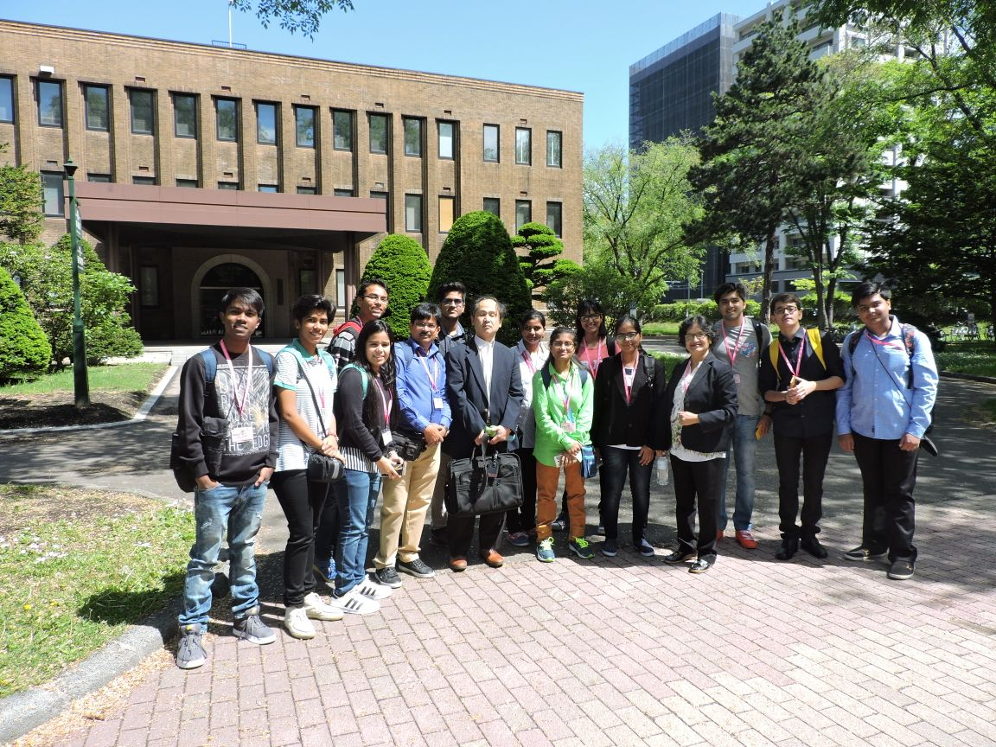*A SNAP AT THE HOKKAIDO UNIVERSITY WITH A PROFESSOR*

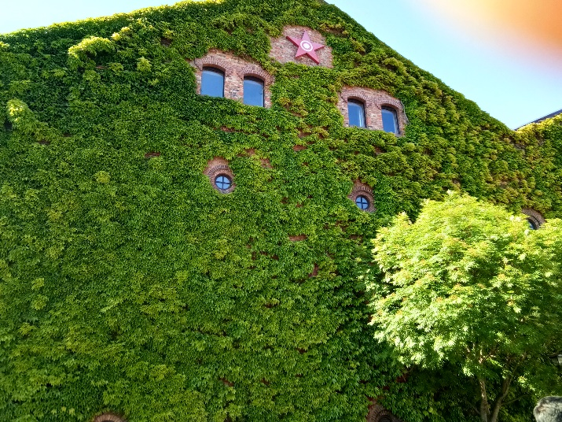*SAPPORO FACTORY*

*DAY 2*

*VISIT TO JAPAN STEEL WORKS*

*We were really impressed by the technologies and techniques used there to develop immensely large tools for basic human uses.*

*NEXT WE VISITED THE MUSEUM OF SWORDS.It was quite a new experience to be there and be able to witness the process of melting iron and how it is transformed into mighty swords.*

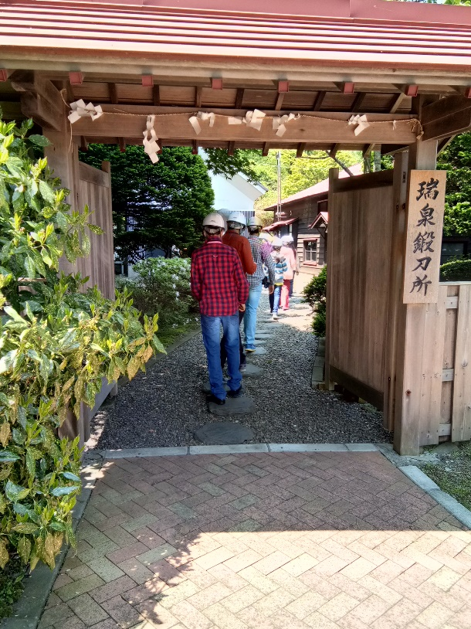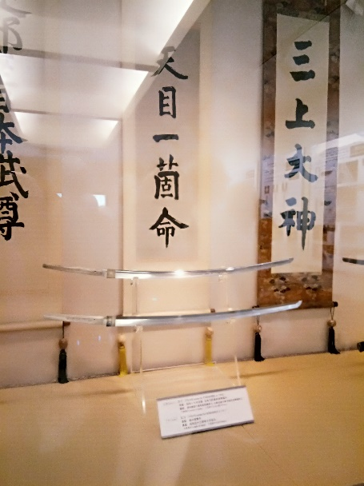

*FEW SNAPS OF THE SWORD MUSEUM*

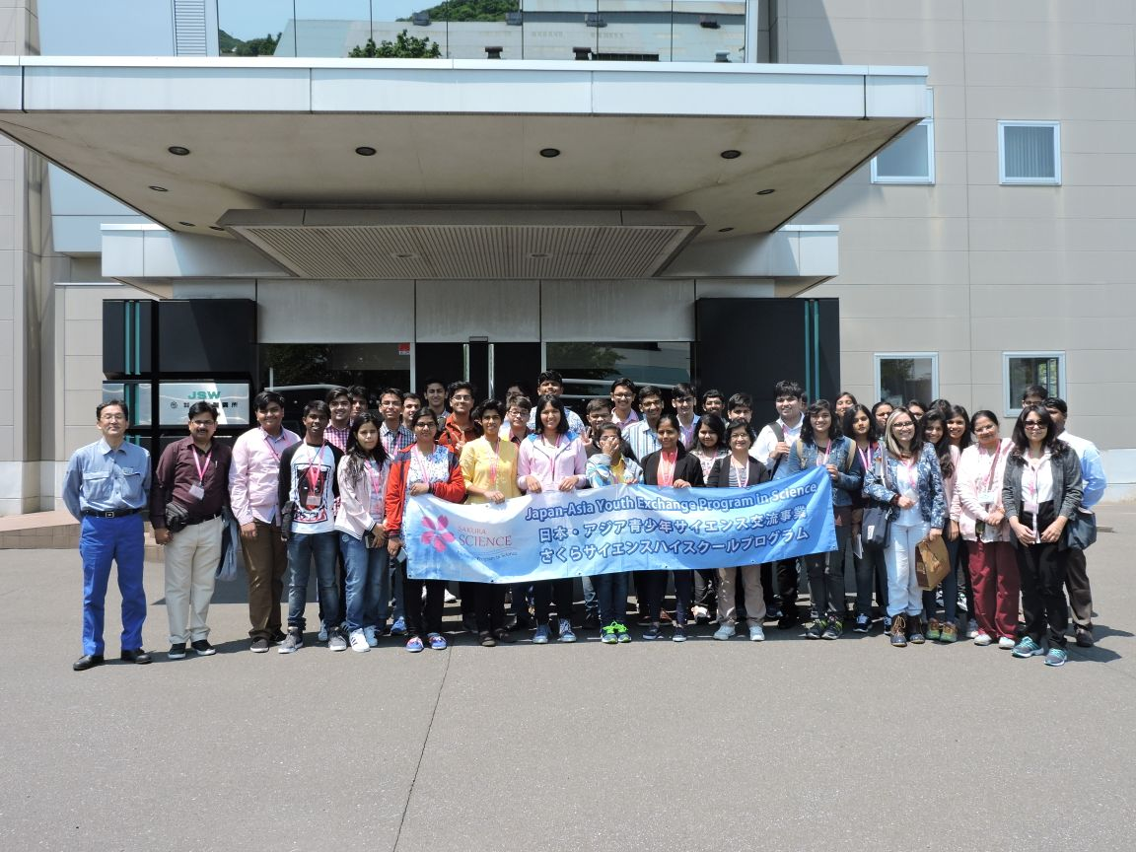*A SNAP AT THE JAPAN STEEL WORKS*

*DAY 3*

*A VISIT TO MIRAIKAN (MUSEUM OF THE FUTURE) IN TOKYO*

*It was extremely grateful of the Japanese science and technology agency to have us visit this museum because it gave an insight into outer space and gadgets used by astronauts in space. They made us experience a gravity free environment. Next, we witnessed a show of the andro humanoid robot ASIMO MADE BY HONDA.It was an extremely enriching experience.*

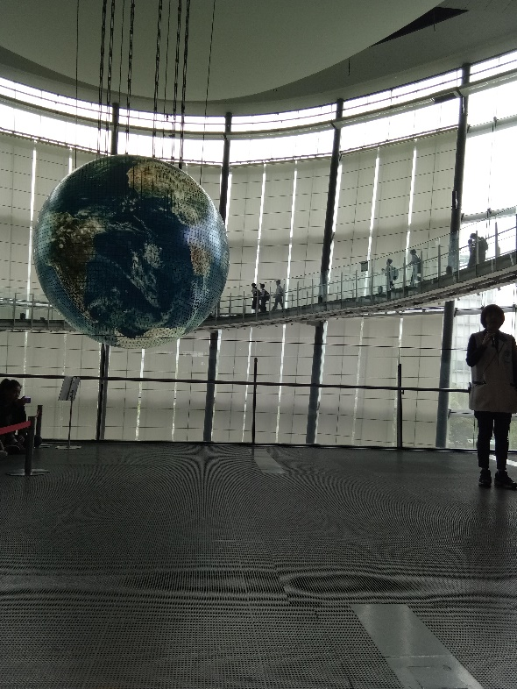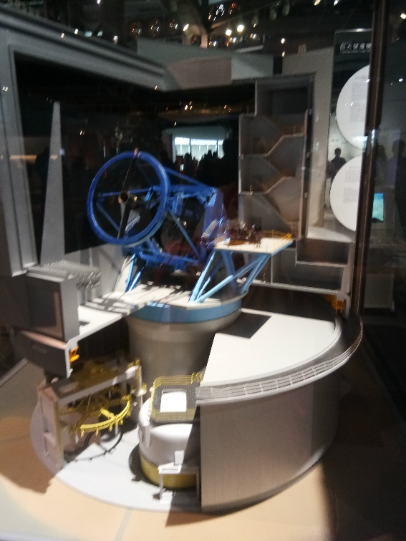

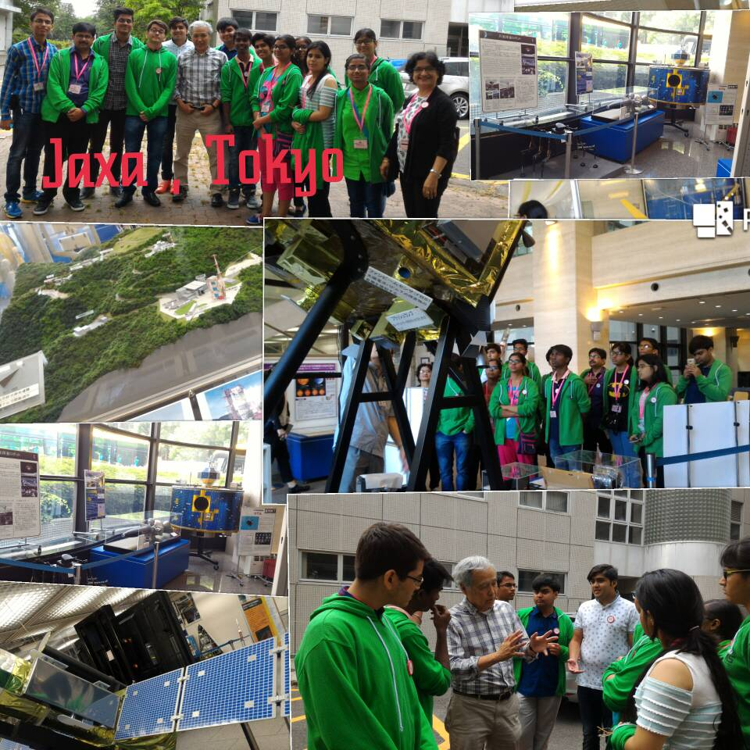

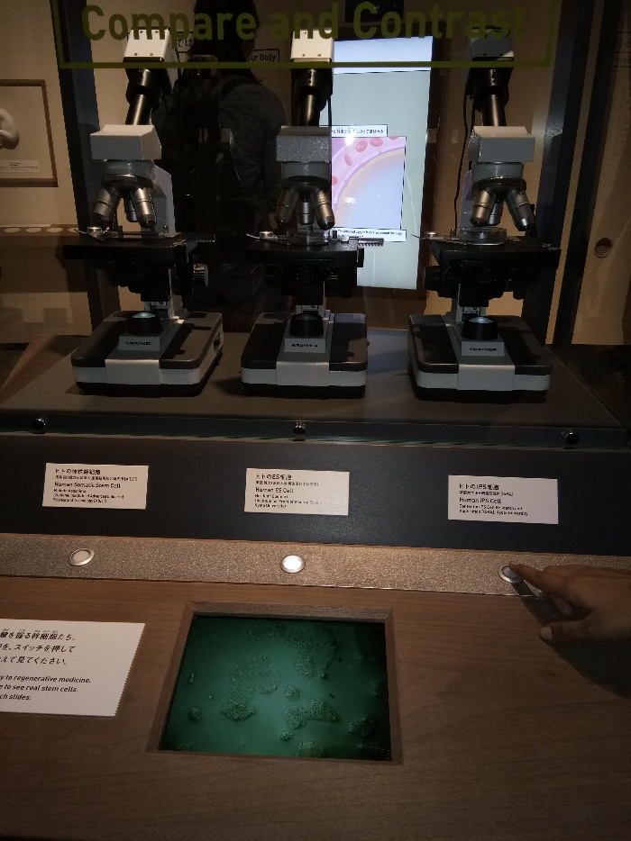*FEW SNAPS INSIDE MIRAIKAN*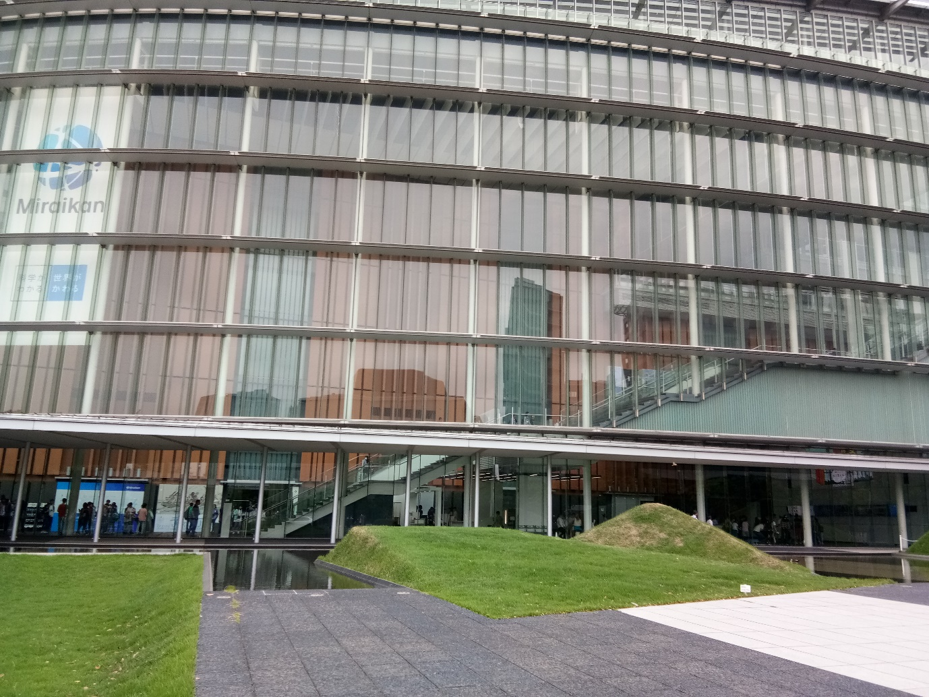

*MIRAIKAN FROM OUTSIDE*

*DAY 4*

*VISIT TO TOKYO GAKUGEI UNIVERSITY INTERNATIONAL SECONDARY SCHOOL*

*We witnessed a lecture by PROF.NOYORI in that school .We also got to interact with a few secondary high school students there. I was extremely amazed to meet and learn intriguing things the students did there for there school and career.*

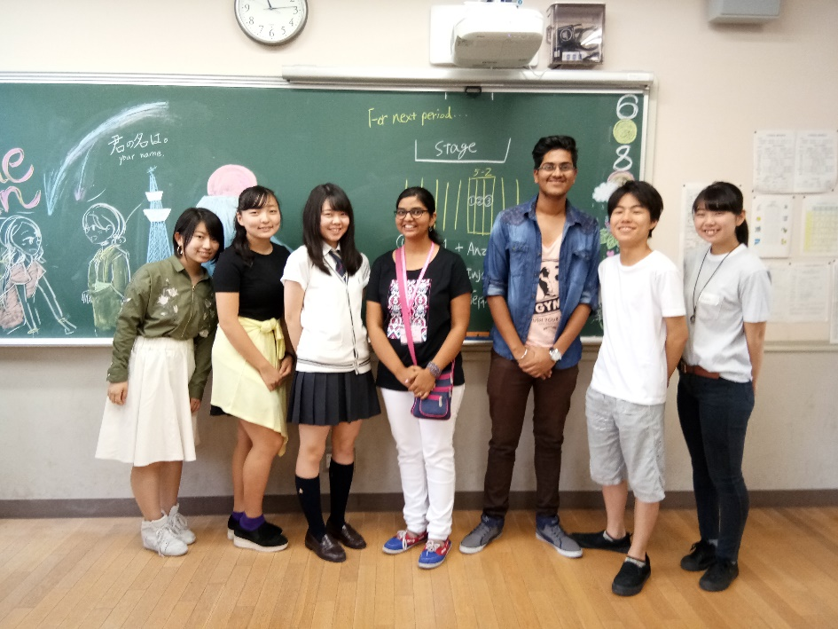

*VISIT TO AKIHABARA*

*The biggest hub of anime culture and electronics was a drool worthy place .We got so much to cherish and remember forever at that place.*

